About Our Company . . .

We are a fabrication and manufact-uring semi custom job shop spec-ializing in steel fabrication both in our shop and on the job site.

Our abilities include steel structure (heavy & light construction), aircraft maintenance stairs, stair-cases, spiral staircases, handrails, guardrails, and used machinery re-furbishing, repairs on heavy equipment (buckets, tracks, etc.) including various other work and new equipment fabrication.

It is our belief that Ameritech Machine Mfg., Inc. can provide your business with a great degree of quality service, professionalism, excellence and experience.

Our facility in Bend, Oregon has been strategically placed to serve the needs of the Western United States.

Manufacturing And
Fabrication
AIRCRAFT
MAINTENANCE
STAIRS
STAIRS AND HAND
RAILS

HEAVY & LIGHT
STEEL CONSTRUCTION

OUR
MISSION STATEMENT

Our ultimate goal is to provide our customers with cost effective fab-rication, quality workmanship and timely service.

Please contact:
Ameritech Machine Mfg., Inc.
at our office location:

350 SW Industrial Way
Bend, Oregon 97702

Or call:
541-322-6905
Toll Free
1-866-322-6905
CCB#148917

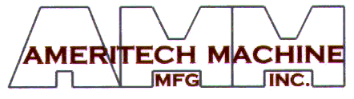

Maintenance Boarding Stairs
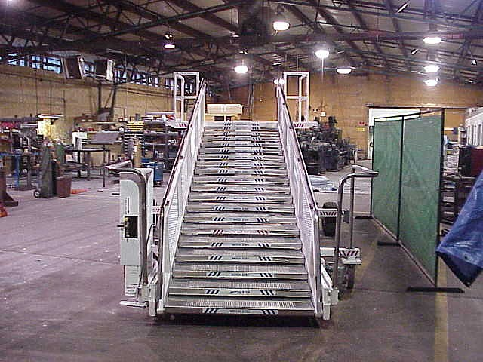
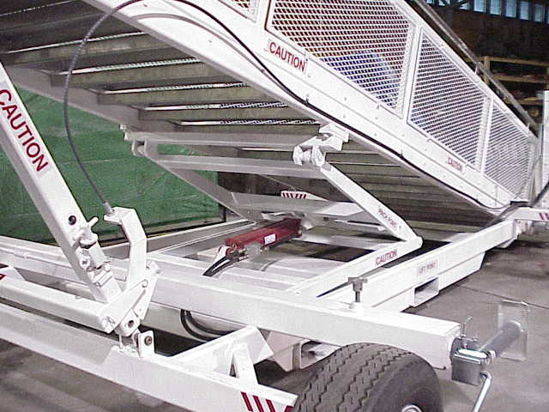
Maintenance Platform

- Low Profile Design

- Adjustable Height from 5'8" to13'6"

- 1 1/2" Incremental Adjustment between 8'6" and 13'6"

- Platform Capacity 1000 lbs

- Shipping & Storage Height 5'8"

- Air over Hydraulic Controls with Manual Override

- Forklift Lifting Pockets

- 10" Steel/Neoprene Swivel Casters

- Stainless Steel Handrail

- 48" Wide Aluminum Steps with Non-Slip Treads

- Padded Bumper

- Optional Canopy

- Optional 12V Electric Control Package

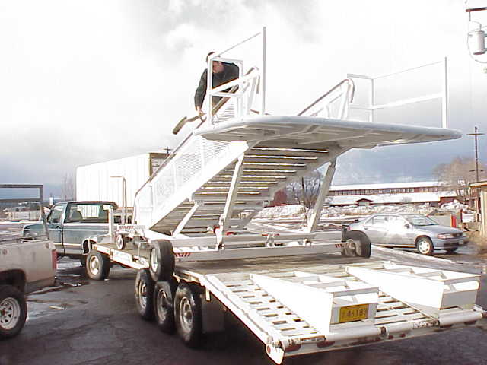

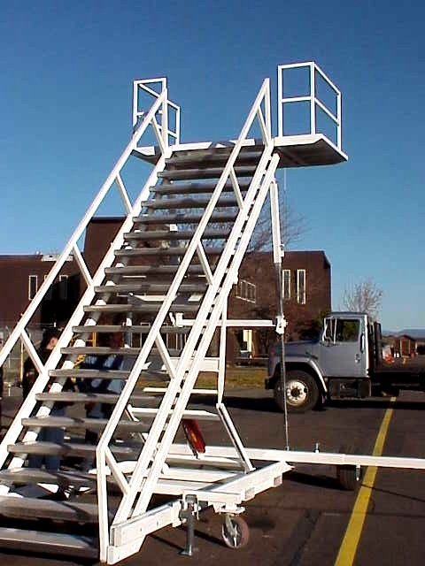
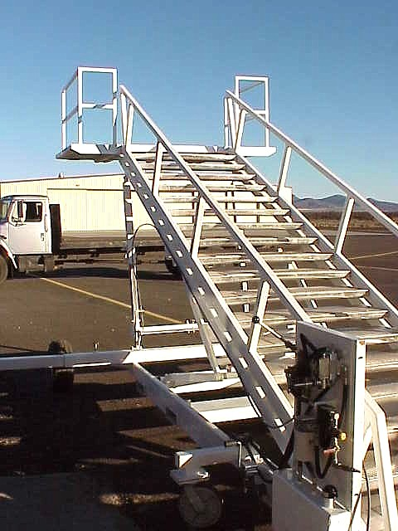
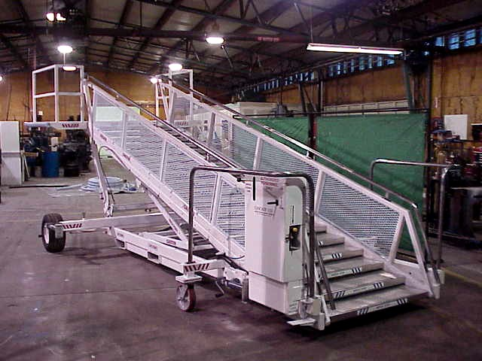
Unfinished
Finished
13'6" Working Height

